Daddy has bumped his head

Daddy has bumped his head

He spent many weeks in bed

But now he’s awake and he looks just the same

But Mummy is sad; “Daddy’s hurt his brain”

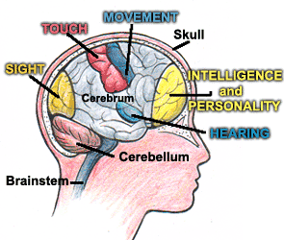

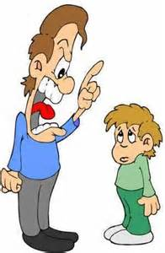

So it isn’t the same as it was before
And when friends come knocking at the door
We try to explain that our Dad’s still our Dad
But he’s different, he’s changed but he’s here and we’re glad

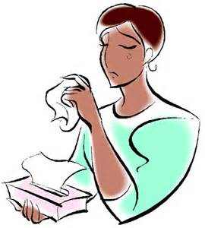

The brain controls all that we do:
What we think, how we feel, what we say
Our walking, our talking our seeing,
Our mood
It even controls how we taste our food

Now Daddy gets tired and sleeps quite a lot
Sometimes he’s happy – and sometimes he’s not
He’s angry or upset, grumpy or sad
But we know he can’t help it so we don’t get mad
He needs to get better and we can help out
We help our Mummy and try not to shout
When Daddy forgets things then we can remind
So he doesn’t leave important things behind

