**Mummy has a poorly head**

Mummy has a poorly head

She spent time in hospital sleeping in bed

But now she’s back home and she looks just the same

But Daddy is sad; “Mummy’s injured her brain”

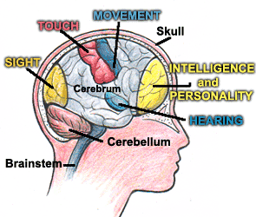

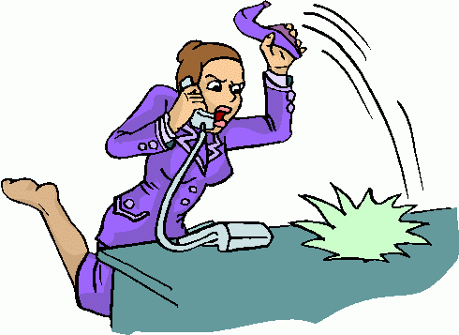

So it isn’t the same as it was before

And when friends come knocking at the door

We try to explain that our Mum’s

Still our Mum

And friends are still welcome

So – “in you come!” ☺



The brain controls all that we do:

What we think, how we feel, what we say

Our walking, our talking our seeing,

Our mood

It even controls how we taste our food

Now Mummy gets tired and sleeps quite a lot;



Sometimes she’s happy – and sometimes she’s not

She’s angry or upset, grumpy or sad

But we know she can’t help it so we don’t get mad

She needs to get better and we can help out

We try to help Daddy and try not to shout

When Mummy forgets things then we can remind

So she doesn’t leave important things behind

C:\Users\Julie\AppData\Local\Microsoft\Windows\INetCache\IE\F58ODIVK\MC900445706[1].wmf