HEADWAY SUFFOLK CYCLE RIDE AND WALK 2020
SPONSORSHIP AND GIFT AID DECLARATION FORM
Saturday 5 September at 9.00am

28 mile circular CYCLE route from Headway, West Road, Ipswich IP3 9FJ
+ optional extra 10 mile loop taking in Newbourne Fox and a further 10 mile extension
10 MILE CIRCULAR WALK

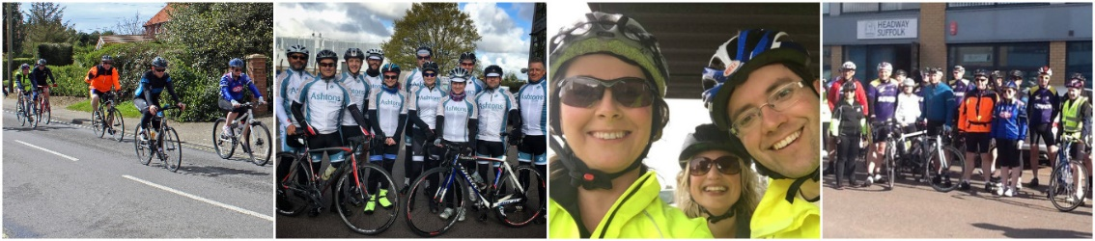

Please sponsor me (name of participant) ______________________________________________ of

(home address) ____________________________________________________________________

Age (if under 18 ______________________ Date of birth (if under 18) ________________________

Tel No ________________________________ Mobile _____________________________________

Email address _____________________________________________________________________

If I have ticked the box headed “Gift Aid?” below, I confirm that I am a UK Income or Capital Gains taxpayer. I have read this statement and want Headway Suffolk to reclaim tax on the donation detailed below, given on the date shown. I understand that if I pay less Income Tax / or Capital Gains tax in the current tax year than the amount of Gift Aid claimed on all my donations it is my responsibility to pay any difference. I understand Headway Suffolk will reclaim 25p of tax on every £1 that I have given.

Remember: You must provide your full name, home address including postcode & tick the “Gift Aid?” box for Headway Suffolk to claim tax back on your donation.
Date | Name (In full) | Home address (In full including postcode) | Amount | Gift Aid? | Date paid
Totals
Date | Name (In full) | Home address (In full including postcode) | Amount | Gift Aid? | Date paid
Totals

