HEADWAY SUFFOLK CYCLE RIDE AND WALK 2021
SPONSORSHIP AND GIFT AID DECLARATION FORM
Saturday September 4th at 9.00am

28 mile circular CYCLE route from Headway, West Road, Ransomes Europark, Ipswich IP3 9FJ
+ optional extra 10 mile loop taking in Newbourne Fox and a further 10 mile extension
10 MILE CIRCULAR WALK

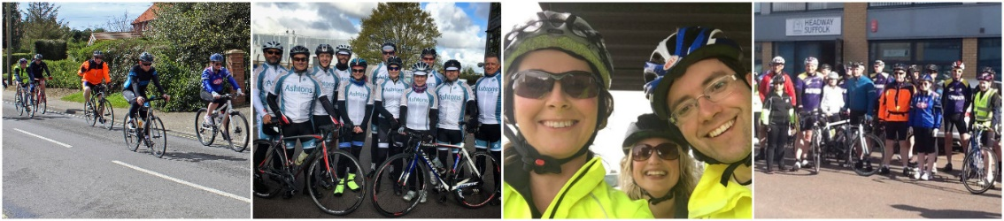

Please sponsor me (name of participant) ______________________________________________ of

(home address) ____________________________________________________________________

Age (if under 18 ______________________ Date of birth (if under 18) ________________________

Tel No ________________________________ Mobile _____________________________________

Email address _____________________________________________________________________

If I have ticked the box headed “Gift Aid?” below, I confirm that I am a UK Income or Capital Gains taxpayer. I have read this statement and want Headway Suffolk to reclaim tax on the donation detailed below, given on the date shown. I understand that if I pay less Income Tax / or Capital Gains tax in the current tax year than the amount of Gift Aid claimed on all my donations it is my responsibility to pay any difference. I understand Headway Suffolk will reclaim 25p of tax on every £1 that I have given.

Remember: You must provide your full name, home address including postcode & tick the “Gift Aid?” box for Headway Suffolk to claim tax back on your donation.
Date | Name (In full) | Home address (In full including postcode) | Amount | Gift Aid? | Date paid
Totals
Date | Name (In full) | Home address (In full including postcode) | Amount | Gift Aid? | Date paid
Totals

