Headway Suffolk Newsletter December 2023

Brainy Dogs wins innovation award

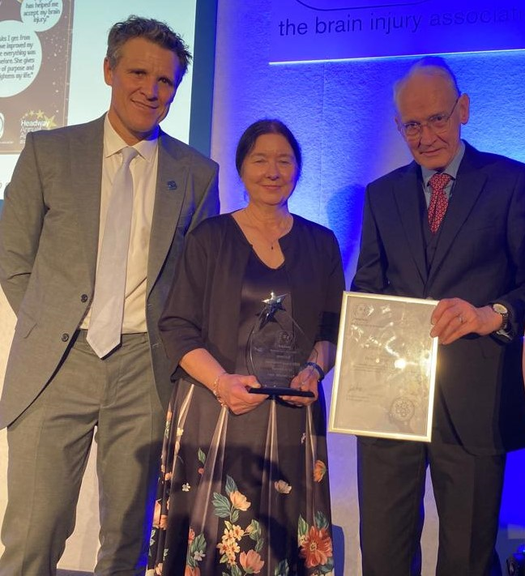

When Helen Fairweather CEO of Headway Suffolk picked up the book Endal in 2012 little did she realise that as a result in 2023 Headway Suffolk would be awarded a prize for the most innovative project for Brain injured survivors.

Endal was the runt of the litter who became a companion dog to Admiral Allan Patron who sustained a brain injury in the first Iraq War.

Helen realised that her clients would benefit from an Endal. After winning peoples million, a lottery project, in 2011 Brainy dogs was born. HEADWAY Suffolk trained rescue dogs to be companions to Brain injured Survivors. Helen said as a result of brain injury people's personality changes this results in loss of friends and relationship breakdown. Dogs give unconditional love.
Headway Suffolk was presented the award at the Landmark Hotel London on 8th Dec.

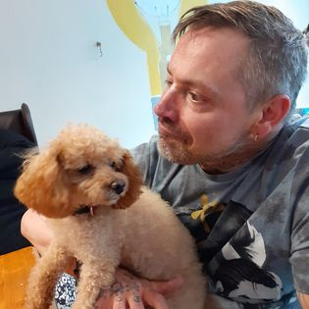

Staff Big Dip

Headway Suffolk staff, together with staff from our supporters at Ellisons Solicitors, are taking part in a Big New Year dip, on Friday 5th of January 2024 .They are meeting at Mannings in Felixstowe at 12 noon. After their dip they will enjoy a much deserved portion of fish and chips. Clients are welcome to come along and watch, as our supporters. It would be really great if the staff team were supported and were given lots of sponsorship money. All the money raised will go towards the services of Headway Suffolk. The trustees and management of Headway Suffolk would like to thank the staff and Ellisons Solicitor for doing this, their second dip, which is becoming an annual event.

New Fundraising platform and approach
In these very difficult times, the Board of Trustees and management are having to look at how the Charity Fund Raises. We are talking to People's fundraising, which is a charity set up to help charities to fundraise. The link below shows how you can donate to Headway Suffolk. During 2024 we will be working on this platform and opening an Online shop .We will also be having auctions and raffles . You can take part in these from the comfort and warmth of your own home .If you have any ideas on how we can fundraise, please do not hesitate to let the management and staff of Headway Suffolk know

Donations - Headway Suffolk (peoplesfundraising.com)
Air Fryer Courses
During these difficult times, Headway Suffolk are looking at how they can help the clients with the cost of living. We have been able to gain Lottery funding to purchase air fryers. We are offering free courses to anybody with a neurological condition on how to use an air fryer. At the end of the course participants will be given an air fryer to take home to use. Numbers are limited, so we encourage people to apply for a place on the course as soon as possible. These courses will be held all of our hubs. To apply to go on a course, please e-mail helenmfairweather@headwaysuffolk.org.uk.

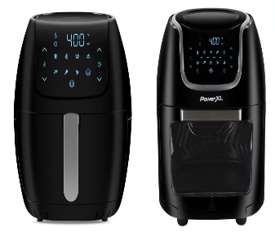

New Hubs
We're proud to say that we have already opened additional hubs in Hadleigh and Newmarket. During 2024, we'll be opening hubs in Leiston, Sudbury and Haverhill. We will be talking to local residents to see if there are any other towns that would benefit from our services. To find out more about the hubs and their opening times please consult our website or e-mail helenmfairweather@headwaysuffolk.org.uk. At all of the hubs, we'll be offering Understanding Brain Injury courses, as well as lots of activities such as, art and craft ,IT, music, cognitive games and cognitive exercises. All of these will be delivered by trained rehab assistants and our clinical team.

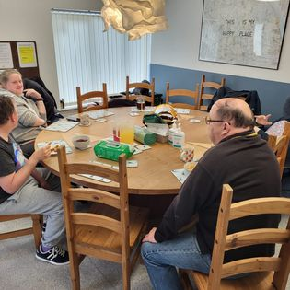

Respite/ Holidays
For a number of years we have been concerned that when our clients return to us after respite, they have regressed. This makes it traumatic for them and their family carers. During 2023 we piloted holidays. We had a group holiday at Wroxham, sailing, canoeing and boating on the Boards which was enjoyed by all .We noticed a rapid improvement of the clients on their return with greater independence, mobility and confidence. We took one individual away on a holiday in a purpose built adapted caravan for people with disabilities. Again on his return, his rehabilitation journey had greatly accelerated. We are therefore offering holidays to anybody with a neurological condition during 2024. We will help you to gain funding from Social Care or CHC. If you're not entitled to this funding, then of course you can pay privately. To find out more, please consult our website. Or contact our chief executive Helen Fairweather.

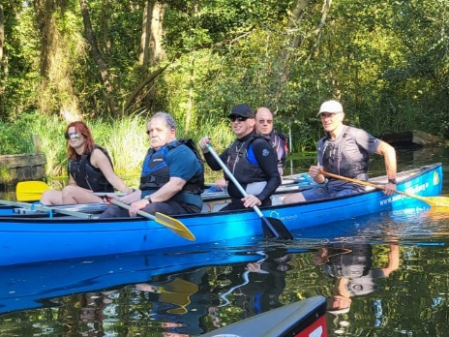
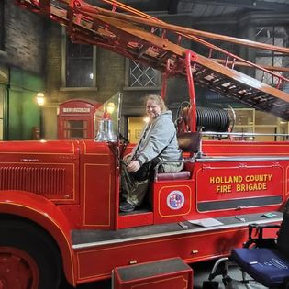

Neuro Conference 2024-
Sponsored by Ellisons Solicitors
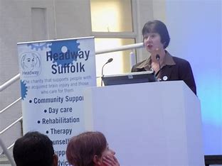

Headway Suffolk’s Neuro Conference 2024 is already planned. As you'll see below, we have an exciting program of guest speakers talking about a range of topics. The conference will be held at Kesgrave Conference Hall, on May 15th . Tickets are now available online. We are also looking for sponsorship and people who may like to have an information stand.

Program
15th May 2024 Kesgrave Conference Centre Twelve Acre Approach, Ipswich IP5 1JF
Tickets from helenmfairweather@headwaysuffolk.org.uk £45 per person

10 .00 Introduction and welcome Helen Fairweather- CEO Headway Suffolk

10.15 Helen Fairweather CEO Headway Suffolk- Headway Suffolk’s services and Headway Suffolk case studies-

10.45 Mark Horne- service user stroke journey

11.15 coffee break

11.00 Dr Michelle Kemp obstetric consultant at Addenbrooke’s Hospital - stroke in pregnancy

11.30 Roger Blake (RNLD) Learning Disability and Autism Specialist Nurse

12..00 Karen Finch . All about hearing -loss of hearing and dementia

12.30 Lunch break and trade stands

13.30 Jennie Gow F1 presenter – Jennie’s stroke journey

14.00 Andrew Graham Neuro lead for Suffolk

14.15 tea break and raffle

14.30 Paul Taylor FES

15.00 Dr Anna-Louise Mackinnon, Consultant Sports and Exercise Medical Physician for.Injured Jockey Fund

15.30 Pepper Robot

16 .00 Conclusion- Helen Fairweather
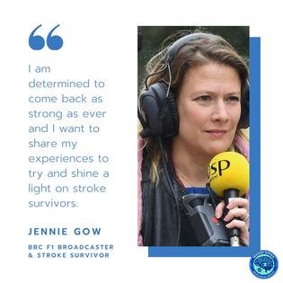

The Board of Trustees and Management and staff wish all our clients and their family carers a safe and happy Christmas and a prosperous 2024 .
We are look forward to working with you during the next year in your rehabilitation journey.

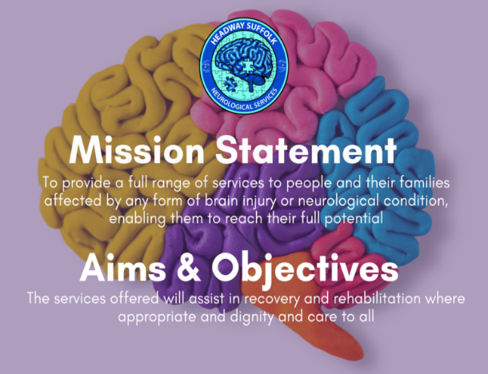

To find out more about any of the subjects above, please consult our website, www.headwaysuffolk.org.uk, our social media pages or e-mail Helen Fairweather on helenmfairweather@headwaysuffolk.org.uk or phone her on 01473712225. We're looking forward to an exciting 2024.

The Board of Trustees and Management and staff wish all our clients and their family carers a safe and happy Christmas and a prosperous 2024 .

We are look forward to working with you during the next year in your rehabilitation journey.

